NVD CVE Information Retrieval and Management Solution (Approach and Logic)

# 1. Logic to the Problem Statement

### Problem Understanding

The core challenge was to create a comprehensive system for retrieving, storing, and presenting Common Vulnerabilities and Exposures (CVE) data from the National Vulnerability Database (NVD).

### Solution Logic

## Key Design Principles

* **Automated Data Retrieval**: Implement a background job to periodically sync CVE data
* **Persistent Storage**: Use SQLite to cache and manage CVE information
* **Flexible API Access**: Create multiple endpoints for different data retrieval needs
* **User-Friendly Interface**: Develop a responsive web application

### Core Logic Implementation

1. **Data Synchronization Strategy**

python

Copy

def sync_cves():

start_index = 0

while True:

*# Fetch CVEs in batches*

data = fetch_cves(start_index)

*# Process and store CVEs*

for vuln in data['vulnerabilities']:

*# Extract relevant information*

cve_record = process_cve_data(vuln)

*# Update or insert in database*

update_database(cve_record)

*# Move to next batch*

start_index += 2000

1. **Data Processing Logic**

* Extract detailed CVE information
* Handle multiple description languages
* Parse CVSS metrics
* Manage database updates to prevent duplicates

# 2. The Approach Used

### Development Methodology

## 1. Analysis Phase

* Research NVD API specifications
* Identify key data requirements
* Define system architecture

## 2. Design Phase

**System Components**

* Backend: Flask Web Application
* Database: SQLite with SQLAlchemy ORM
* Frontend: Responsive HTML/JavaScript
* Synchronization: Background Scheduler

**Key Design Decisions**

* Use APScheduler for periodic updates
* Implement pagination for performance
* Create flexible API endpoints

## 3. Implementation Challenges

1. **API Rate Limiting**

* Challenge: NVD API has request limitations
* Solution:
  + Implement batch processing
  + Add exponential backoff mechanism
  + Use API key for increased limits

1. **Data Consistency**

* Challenge: Handling frequent CVE updates
* Solution:

python

Copy

*# Merge logic to prevent duplicate entries*

existing_cve = CVE.query.get(cve['id'])

if existing_cve:

if existing_cve.last_modified < cve_record.last_modified:

db.session.merge(cve_record)

else:

db.session.add(cve_record)

1. **Performance Optimization**

* Implemented pagination
* Used efficient database querying
* Minimized API call overhead

## 4. Testing Strategy

* Unit tests for API endpoints
* Database interaction verification
* Error handling scenarios

### Technologies Utilized

* **Backend**: Python, Flask
* **Database**: SQLite, SQLAlchemy
* **API Interaction**: Requests library
* **Scheduling**: APScheduler
* **Frontend**: Vanilla JavaScript, HTML5
* **Testing**: Pytest

# 3. Input and Output Screenshots

### Input Scenarios

1. **CVE List View** Show Image

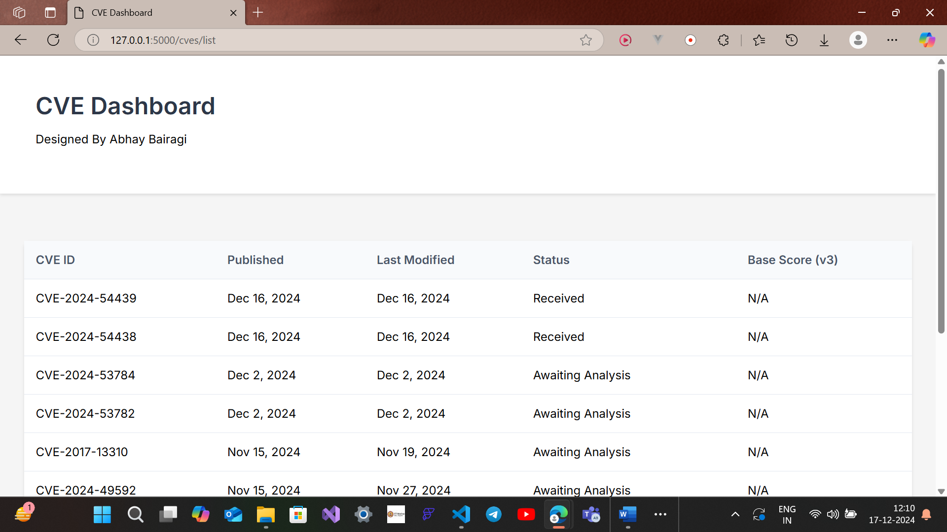

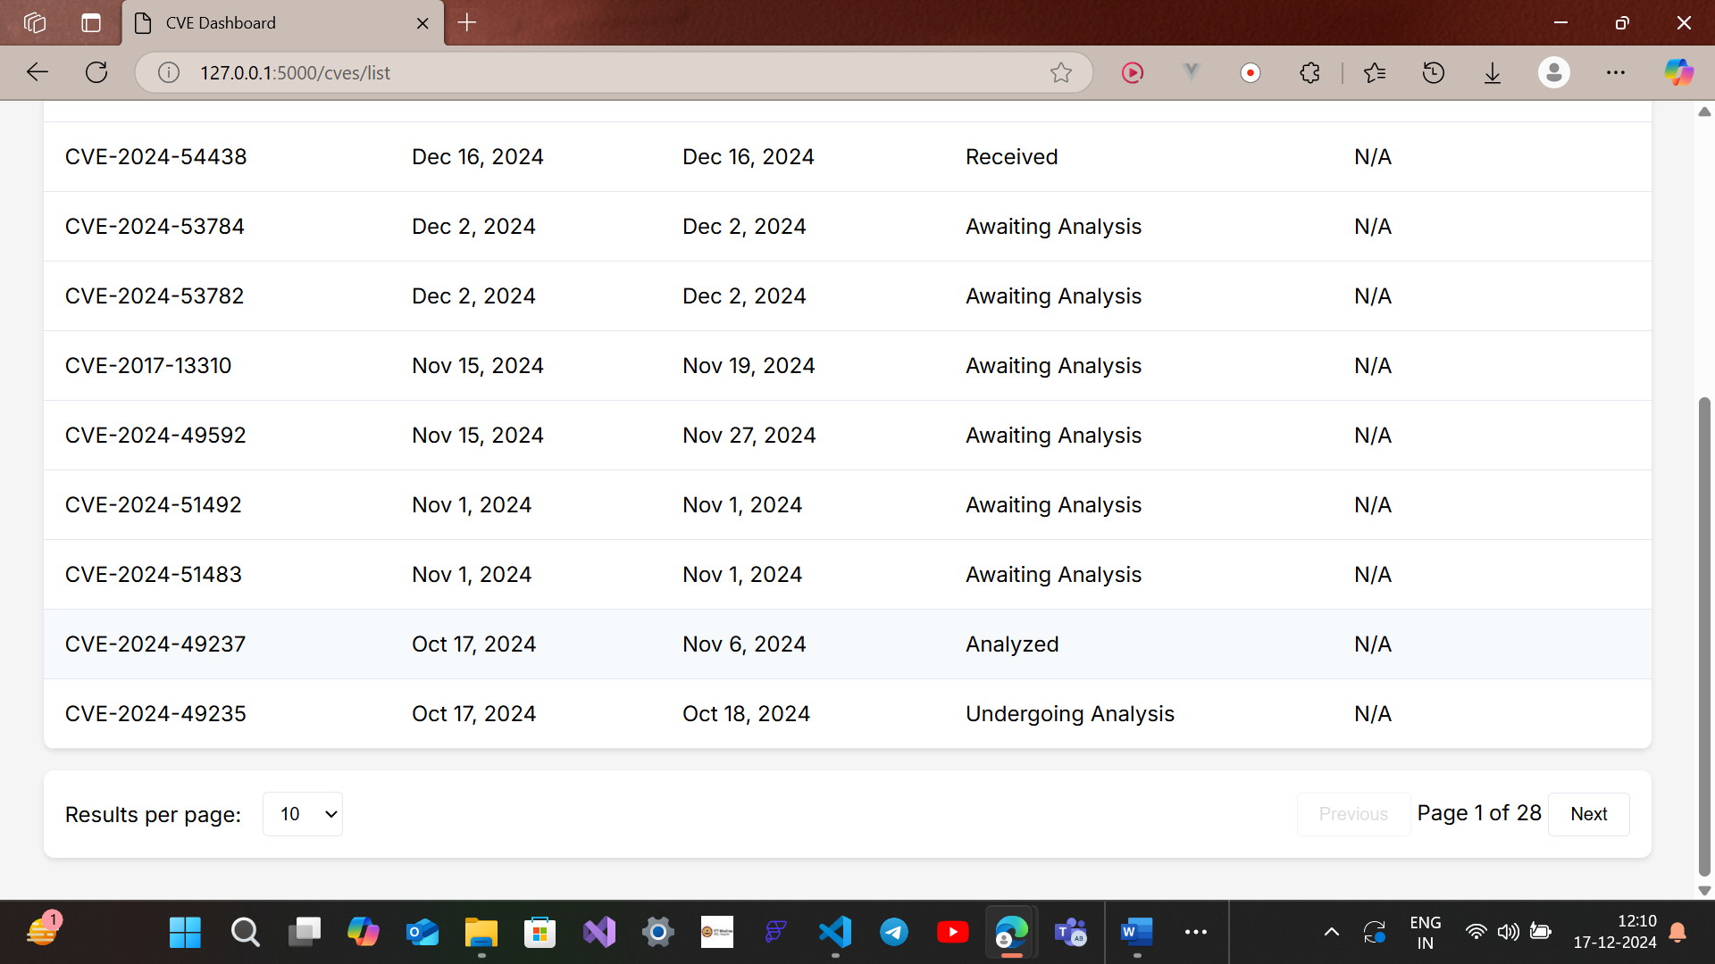

* Shows paginated list of CVEs
* Demonstrates filtering and pagination

1. **CVE Details View** Show Image

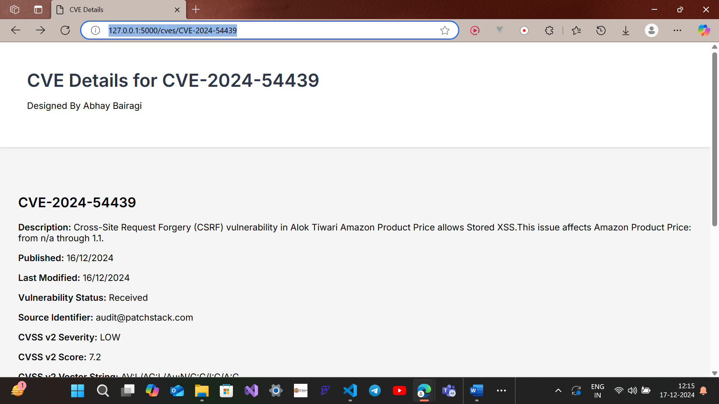

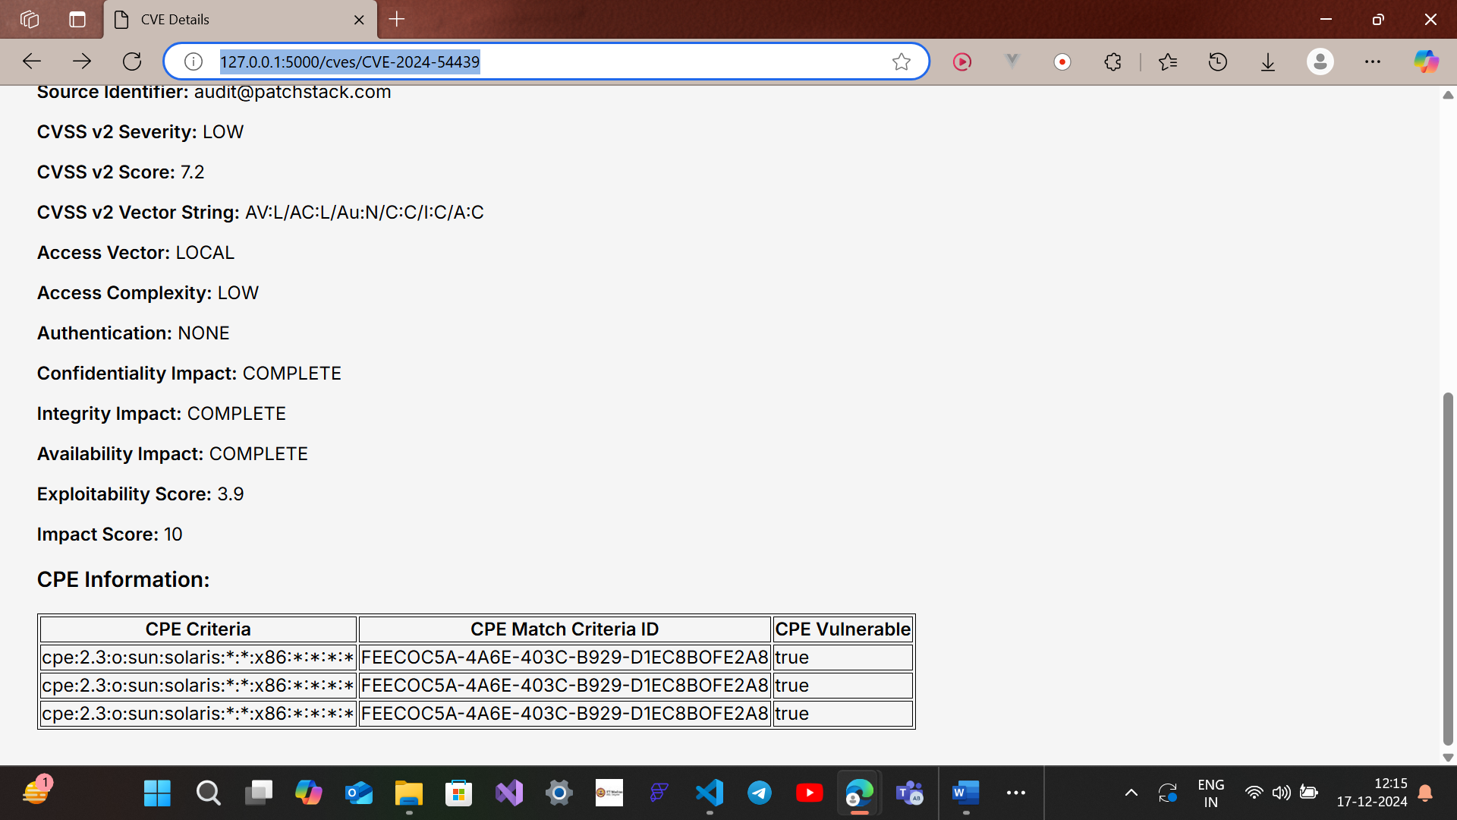

* Displays comprehensive vulnerability information
* Shows parsing of complex CVE metadata

1. API Docs  
   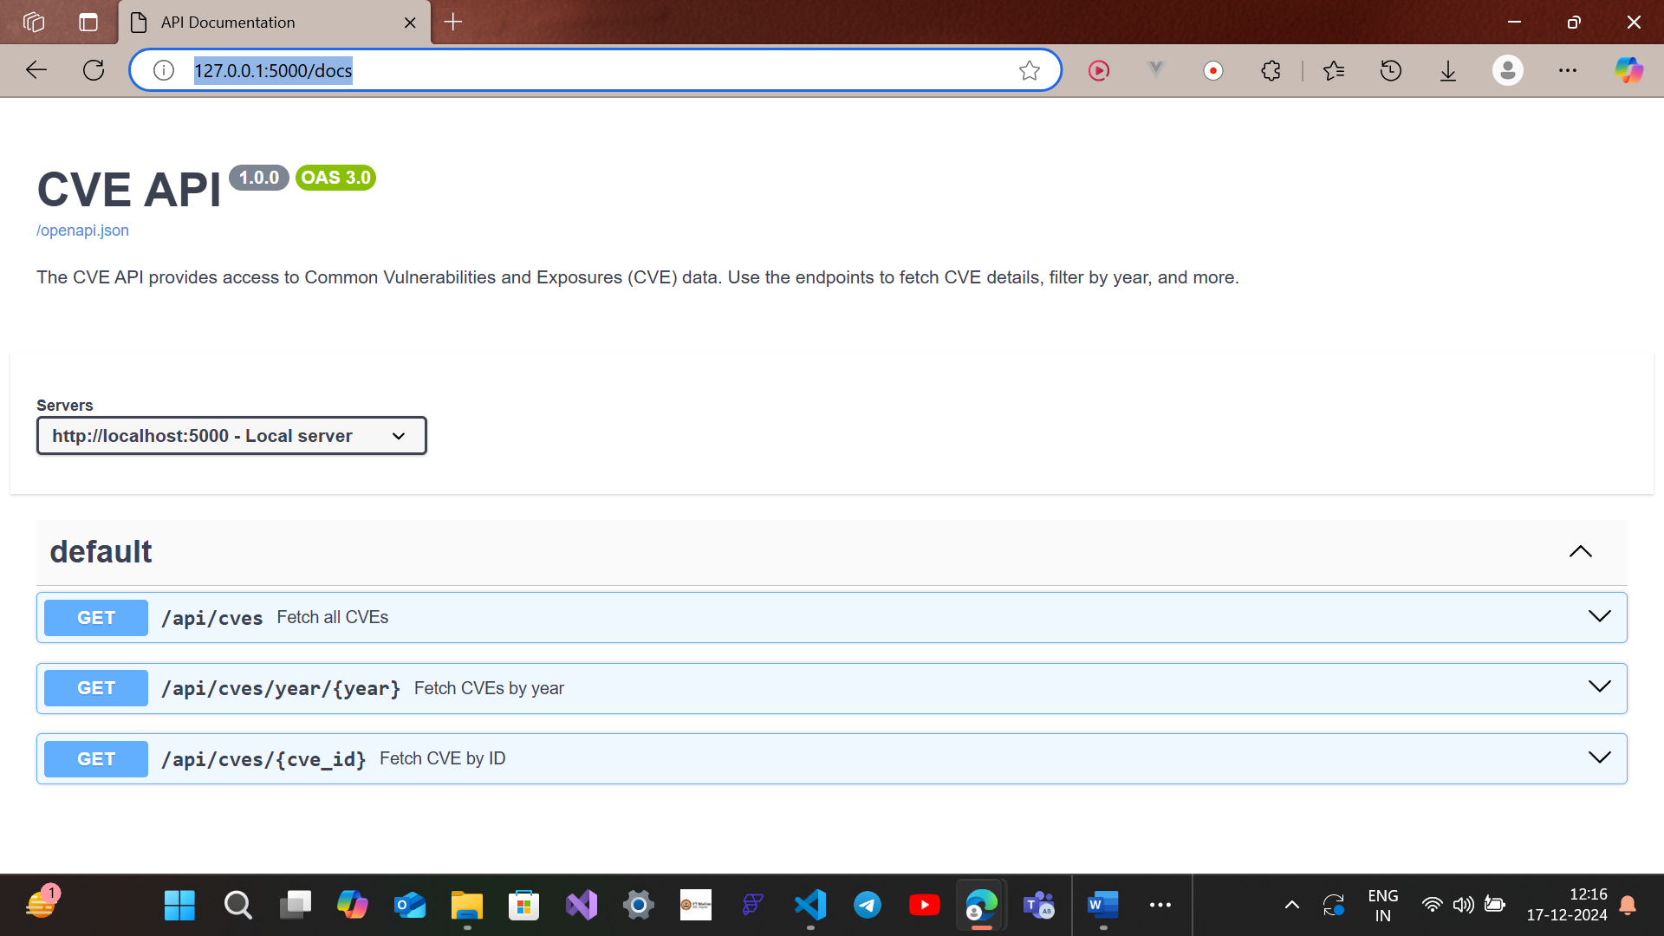

### Edge Case Handling

1. **No CVEs Found** Show Image

* Graceful handling of empty data scenarios
* User-friendly error messaging

## Conclusion

A robust solution addressing the complex challenge of CVE data retrieval and management, with a focus on:

* Automated synchronization
* Comprehensive data processing
* User-friendly interface
* Scalable architecture

### Future Improvements

* Enhanced search capabilities
* Real-time vulnerability tracking
* Advanced filtering mechanisms
* Improved error handling and logging